BED 106 — BUSINESS ANALYTICS
Mini Business Analytics Capstone Project
RetailPulse
Poblacion Grocery Mart — Integrated Capstone Report
Business Domain: Retail & Sales Analytics
Checkpoint 4 — Final Capstone Analytics Project & Defense
Group Name: Arowana Kings
Member Name | Role
Angel Frederick Paredes | Lead Developer / Project Lead
Jeeruz Marl Tabar | Research Support
Luke Kibry Jao | Testing Support
Clein Lord Will Surigao | Documentation Review
Instructor: Jessie A. Melendres
Talibon Polytechnic College
A.Y. 2026–2027 | 1st Semester

2. Executive Summary
A one-page synopsis of the business problem, the methods used across all four checkpoints, and the key findings. This section should be written last, once every other section is finalized — it is a compressed version of the whole report, not a new analysis.
Poblacion Grocery Mart, a small grocery store in Poblacion, Talibon, Bohol, has never had a structured way to tell which product categories actually drive revenue versus which ones just take up shelf space. Because of this, restocking, pricing, and promotion decisions have mostly been based on gut feel rather than data, which is a risky way to run a business with thin margins and limited shelf space.
To address this, the project moved through four checkpoints. We first designed and populated a four-table relational database in MySQL and wrote eight SQL queries covering filtering, aggregation, and joins (CP1). We then used Excel to run descriptive statistics, correlation analysis, and category-level profitability, flagging outlier products using z-scores and the IQR rule (CP2). From there, we built a four-page interactive Power BI dashboard and used K-Means clustering to segment all 40 products into three groups based on revenue, units sold, and margin (CP3). Finally, in this checkpoint we built two predictive models — a multiple linear regression for product revenue and a trend-based forecast for monthly store revenue (CP4).
The single most important finding is the revenue regression model itself: it explains 95% of the variation in product revenue (R² = 0.9501), and shows that unit price carries roughly 3.4× more revenue leverage than units sold (₱420.51 vs. ₱123.90 per unit increase). This means pricing decisions move total revenue far more than simply trying to sell more units. The K-Means segmentation adds an important layer to this — it shows the store's 40 products fall into three very different groups: a small set of high-ticket anchor items that generate huge revenue at thinner margins, a mid-size group of core revenue drivers, and a large group of everyday, high-margin earners.
Our top two recommendations for Poblacion Grocery Mart are: (1) prioritize pricing strategy over volume-based promotions, since price has significantly more influence on revenue, and (2) manage the three product segments differently instead of treating all 40 products the same way — protecting margins on everyday earners while making sure high-ticket anchor items are never out of stock.

3. Business Problem & Data Source

3.1 Business Domain and Problem
Domain: Retail & Sales Analytics.
Business context: A grocery/supermarket-style retail store ("Poblacion Grocery Mart") operating in Poblacion, Talibon, Bohol — the commercial center of northern Bohol.
Problem: Grocery stores carry dozens of products across many categories, but without structured sales analysis, owners often cannot tell which categories actually drive revenue versus which merely occupy shelf space. Restocking, promotion, and pricing decisions end up based on intuition rather than data.

3.2 Why This Problem Matters
This problem matters because small-town retailers like Poblacion Grocery Mart operate on thin margins and limited shelf space, so every peso spent restocking a weak-performing category is a peso not spent on a category that could be earning more. Without data to guide these decisions, the owner risks over-investing in products that feel popular but don't actually contribute much profit, while under-investing in categories that quietly generate strong margins. Solving this gives the store a repeatable, evidence-based way to make pricing, promotion, and restocking decisions instead of relying on intuition alone.

3.3 Key Business Questions
- Which product categories generate the most revenue for the store?
- Are high-revenue categories driven by high prices, high sales volume, or both?
- How does revenue behave across the 6-month period — are there noticeable peaks (e.g., payday, holidays)?

3.4 Data Source
Field | Value
Dataset name | Poblacion Grocery Mart Sales Dataset
Source | Structured following the Supermart Grocery Sales – Retail Analytics Dataset (Kaggle, 2022); localized for this project
Period covered | January 1, 2026 – June 30, 2026
Row counts | 9 categories, 40 products, 2,532 transactions, 10,087 line items
License | Reference dataset (Kaggle) is CC0/Public Domain; localized data has no external license
Note: Real point-of-sale data from a specific business in Poblacion, Talibon was not available with proper owner consent for this project. The dataset structure and category conventions follow the Supermart Grocery Sales – Retail Analytics Dataset (Kaggle, 2022, https://www.kaggle.com/datasets/mohamedharris/supermart-grocery-sales-retail-analytics-dataset). Transaction records were localized to model plausible sales behavior for a small-town Bohol grocery store (product mix, PHP pricing, and payday/weekend demand patterns).

4. Database Design & SQL Analysis

4.1 Relational Schema
Four related tables were designed and populated in MySQL: categories, products, transactions, and transaction_items, linked by primary/foreign keys (category_id, product_id, transaction_id). Full ERD, schema screenshots, and populated-table screenshots are in the Checkpoint 1 report (attached in Appendix).

4.2 Data Cleaning Summary
Issue Found | Count | Cleaning Step Applied
Duplicate transaction_id rows | 6 | Removed, kept first occurrence
Missing payment_type values | 15 | Recoded to "Unknown"
Inconsistent payment_type labels | 17 | Standardized to Cash / GCash / Credit-Utang
Result: 2,539 raw rows → 2,533 cleaned rows imported into the transactions table.

4.3 SQL Query Report
Eight SQL queries were written and executed against the poblacion_grocery_mart database, satisfying the required mix of WHERE/ORDER BY, GROUP BY with aggregates, JOIN, and business-relevant queries:
# | Query Type | Purpose
1 | SELECT + WHERE/ORDER BY | Products filtered and sorted by unit_price
2 | SELECT + WHERE/ORDER BY | Transactions filtered and sorted by date/total
3 | GROUP BY + aggregate | Transaction totals grouped by payment_type
4 | GROUP BY + aggregate | Monthly revenue totals (sales_month)
5 | JOIN | Products joined to categories
6 | JOIN | Transaction items joined to products
7 | JOIN + GROUP BY (business) | Revenue and profit by category
8 | JOIN + GROUP BY (business) | Revenue and profit by product
Each query below was re-run directly against the poblacion_grocery_mart database (verified against the submitted .sql dump: 9 categories, 40 products, 2,532 transactions, 10,087 line items) to confirm the figures reported throughout this document:
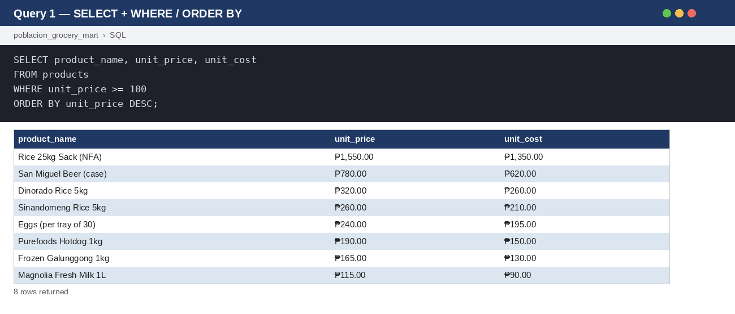
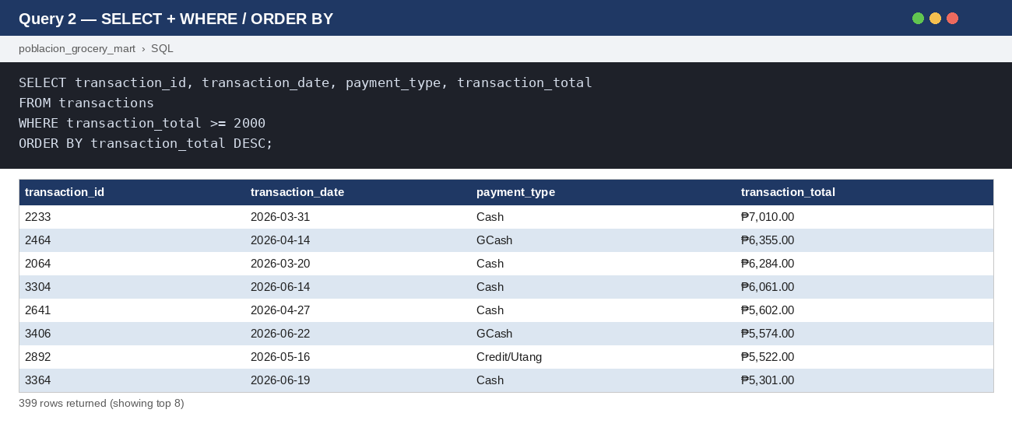
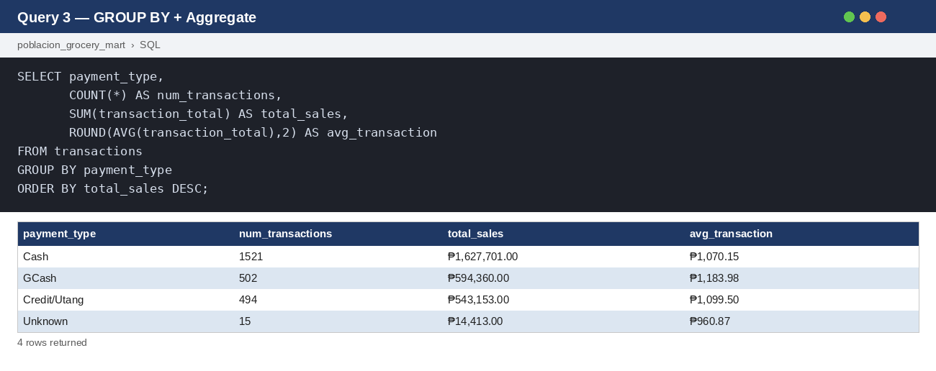
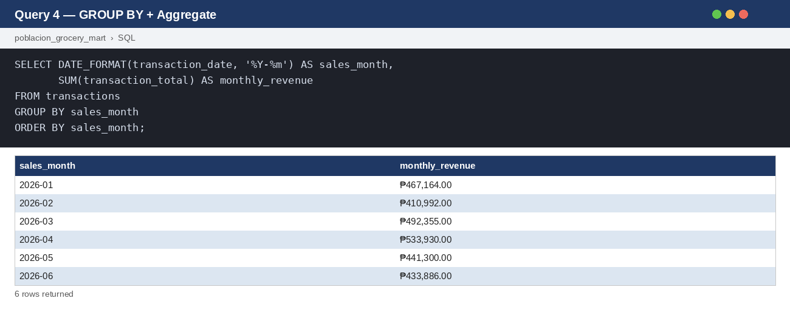
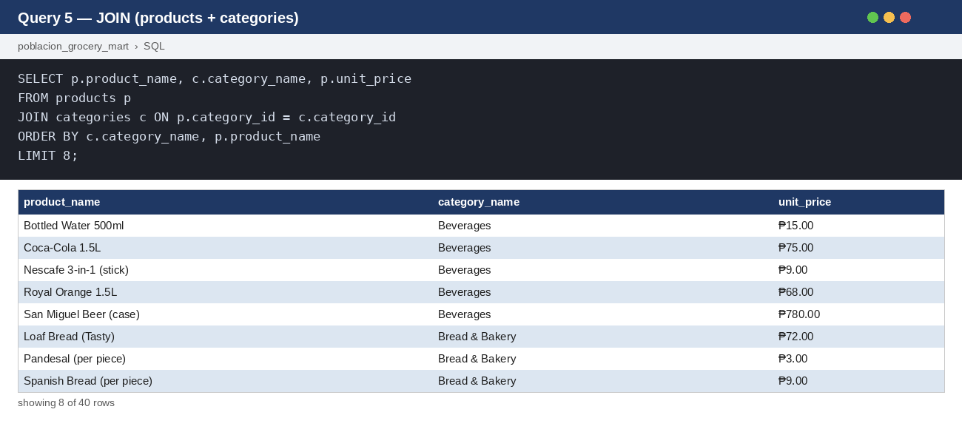
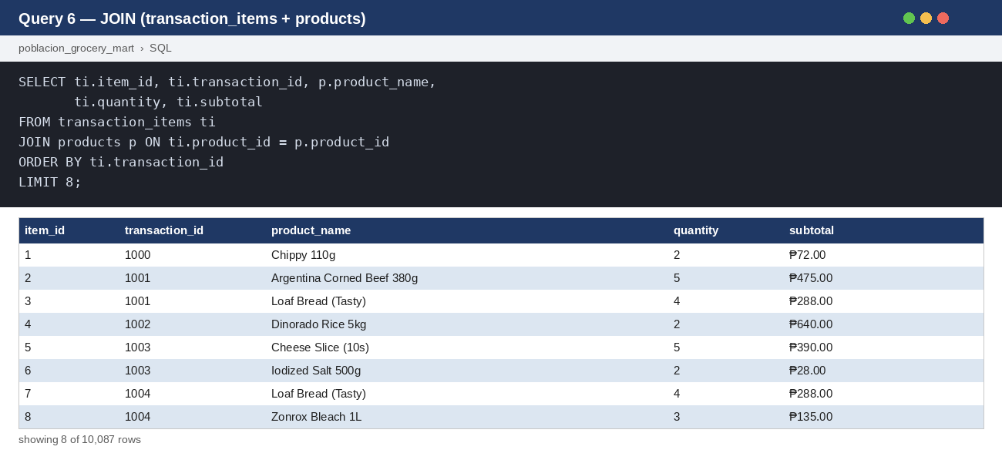
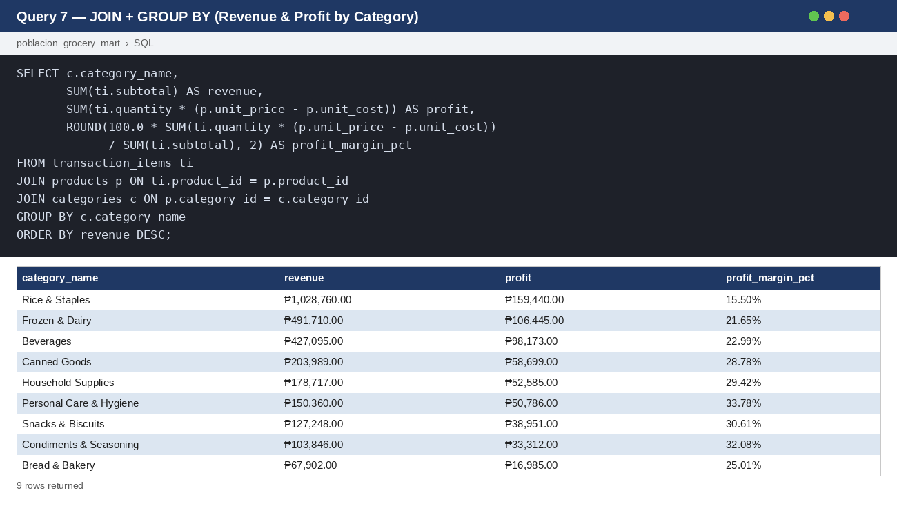
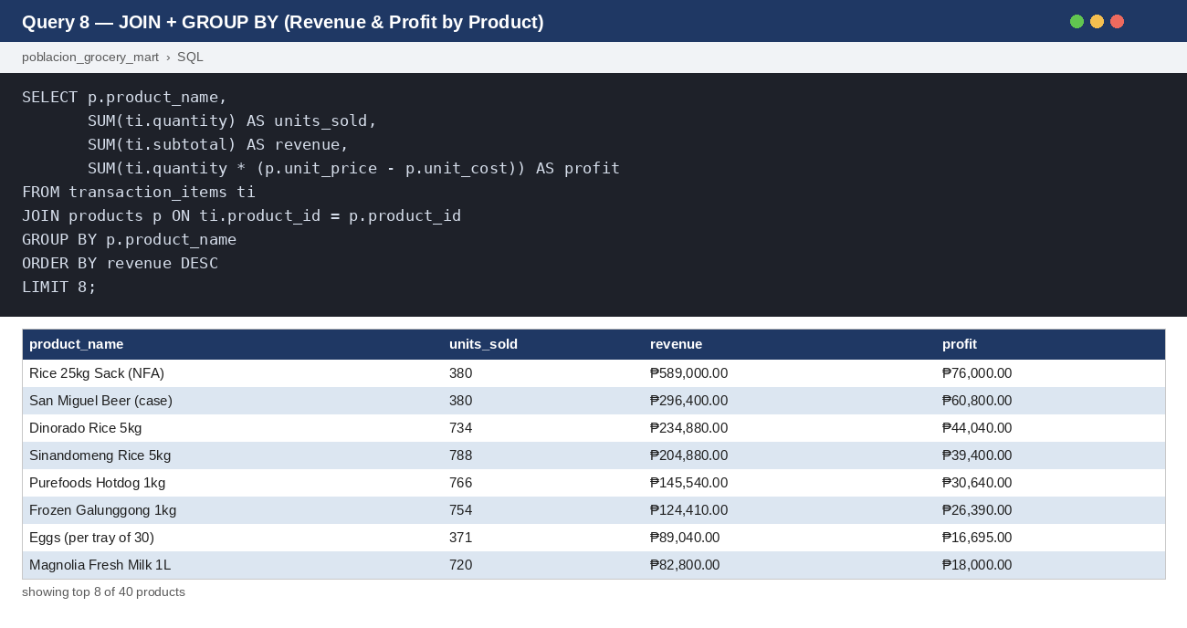

5. Statistical Analysis

5.1 Descriptive Statistics
Computed on total revenue and total units sold, aggregated per product (n = 40 products):
Metric | Total Revenue per Product (₱) | Units Sold per Product
Mean | 69,490.68 | 727.25
Median | 33,408.00 | 755.00
Standard Deviation | 105,410.26 | 114.45
Minimum | 2,328.00 | 371
Maximum | 589,000.00 | 894
Outliers were flagged using a revenue z-score threshold of |z| > 1.0 and the 1.5×IQR rule (Q1 = ₱21,380.50, Q3 = ₱62,605.50, IQR = ₱41,225.00). Five products were flagged as high-revenue outliers: Rice 25kg Sack (z=4.93), San Miguel Beer case (z=2.15), Dinorado Rice 5kg (z=1.57), Sinandomeng Rice 5kg (z=1.28), and Purefoods Hotdog 1kg (IQR only).
These five outliers, mostly bulk rice and canned/bottled goods, are the store's biggest revenue generators by a wide margin, with the Rice 25kg Sack standing far above the rest at z = 4.93. For inventory purposes, this means these specific SKUs should be treated as top restocking priorities, since running out of any of them would hurt total revenue disproportionately compared to a typical product. At the same time, because they're such extreme outliers, they shouldn't be used as a benchmark for how the other 35 "typical" products are expected to perform.

5.2 Correlation Analysis
Variables Compared | r | Strength & Direction
Total Revenue vs. Total Profit | 0.97 | Very strong positive
Units Sold vs. Total Profit | -0.58 | Moderate negative
Total Revenue vs. Profit Margin % | -0.71 | Strong negative
Units Sold vs. Profit Margin % | 0.44 | Moderate positive
The very strong positive correlation between total revenue and total profit (r = 0.97) shows that higher-revenue products are generally also higher-profit products in peso terms, which makes sense on its own. However, the strong negative correlation between total revenue and profit margin % (r = -0.71) tells a different story on a percentage basis: the products that bring in the most revenue tend to have the lowest margins. So high-selling products don't necessarily yield high profit margins — in this store's mix, they tend to trade margin for volume instead.

5.3 Category Performance
Total store revenue (Jan–Jun 2026): ₱2,779,627. Total store profit: ₱615,376.
Category | Revenue (₱) | Profit (₱) | Profit Margin %
Personal Care & Hygiene | 150,360 | 50,786 | 33.78%
Household Supplies | 178,717 | 52,585 | 29.42%
Condiments & Seasoning | 103,846 | 33,312 | 32.08%
Snacks & Biscuits | 127,248 | 38,951 | 30.61%
Canned Goods | 203,989 | 58,699 | 28.78%
Bread & Bakery | 67,902 | 16,985 | 25.01%
Beverages | 427,095 | 98,173 | 22.99%
Frozen & Dairy | 491,710 | 106,445 | 21.65%
Rice & Staples | 1,028,760 | 159,440 | 15.50%
Rice & Staples brings in by far the most revenue (₱1,028,760) but has the lowest profit margin of any category at 15.50%, making it a clear high-volume, low-margin category. On the other end, Personal Care & Hygiene and Condiments & Seasoning bring in much less revenue but carry the highest margins (33.78% and 32.08%), making them low-volume, high-margin categories. Poblacion Grocery Mart should keep Rice & Staples well-stocked since it drives most of the store's overall sales, while also looking for ways to grow the smaller high-margin categories, for example through better shelf placement or small targeted promotions, since every extra peso earned there is more profitable.

5.4 Key Insights
Insight 1: Rice & Staples generates more than twice the revenue of the next-highest category (Frozen & Dairy at ₱491,710), but converts that into the lowest profit margin of all nine categories at just 15.50%.
Insight 2: There's a clear volume-vs-margin tradeoff across categories — the biggest sellers (Rice & Staples, Frozen & Dairy, Beverages) consistently post some of the lowest margins, while lower-revenue categories like Personal Care & Hygiene keep the highest margins.

6. BI Dashboard Summary
The dashboard was built in Power BI Desktop across four pages: Executive Summary, Trend & Comparison, Deep Dive (Segmentation), and a supporting Product Detail drill-through page. A category_name slicer is synced across all three main pages; Sales Month, payment_type, and Segment slicers are page-local, matching the Task 3.1 blueprint.

6.1 Page 1 — Executive Summary
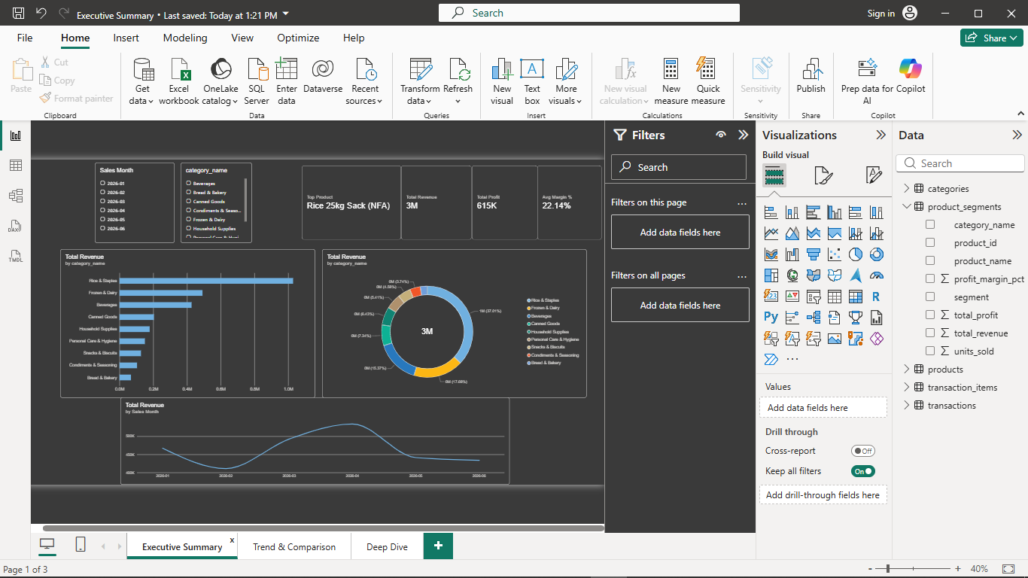
Figure — Executive Summary: 4 KPI cards (Top Product, Total Revenue, Total Profit, Avg Margin%), category bar/donut charts, and monthly revenue trend line.

6.2 Page 2 — Trend & Comparison
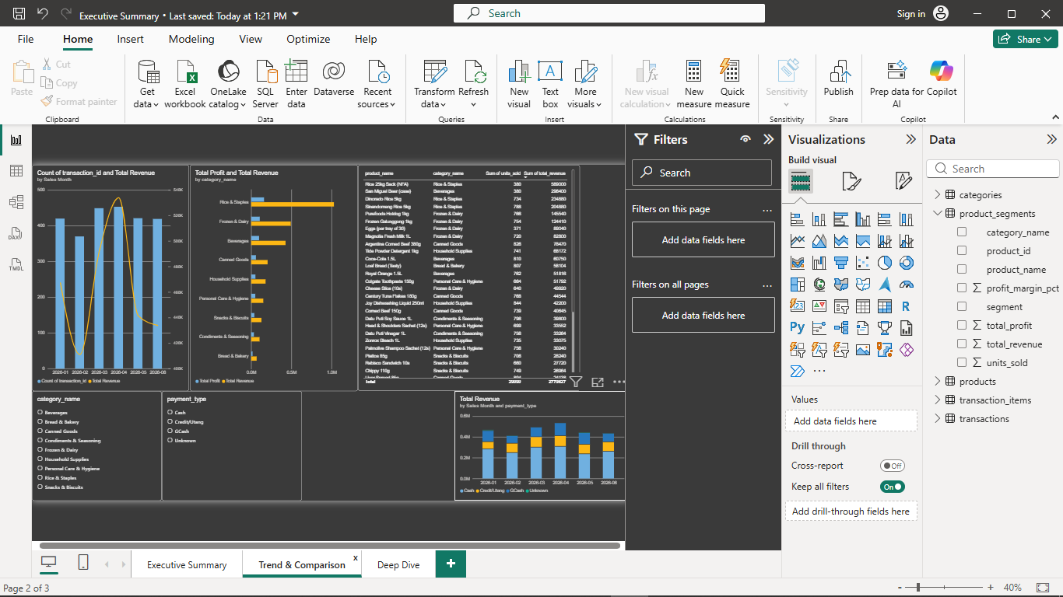
Figure — Trend & Comparison: combo chart (bar + line) for monthly revenue, horizontal bar chart of profit/revenue by category, and a stacked chart by payment type.

6.3 Page 3 — Deep Dive / Segmentation
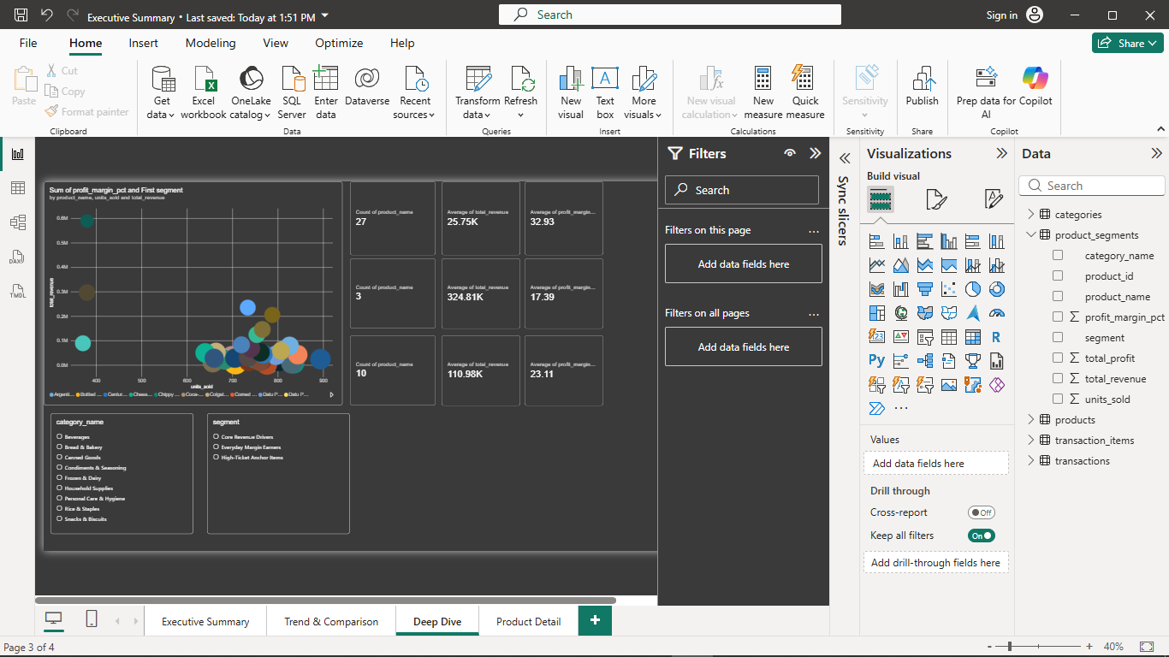
Figure — Deep Dive: scatter plot of products by margin/revenue/units, 9 KPI cards (size, avg revenue, avg margin per segment), and category + segment slicers.

6.4 Product Detail (Drill-Through Page)
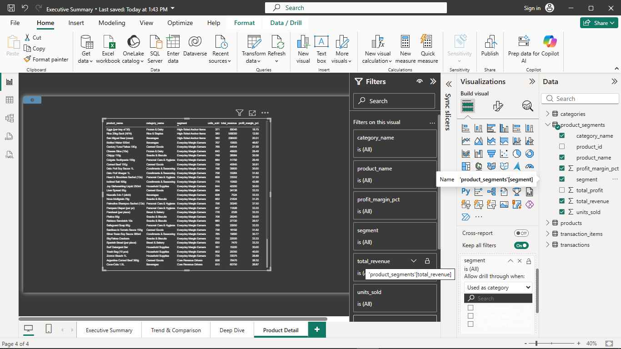
Figure — Product Detail: row-level table (product, category, segment, units sold, revenue, margin) reachable by drill-through from any segment on the Deep Dive page.

6.5 Design Decisions
- Slicer sync: category_name is synced across all pages for consistent cross-page filtering; other slicers (Sales Month, payment_type, Segment) are intentionally page-local per the Task 3.1 blueprint.
- Interaction control: the 9 Deep Dive KPI cards were set to 'None' interaction with the Segment slicer, so they always display fixed totals per segment rather than collapsing when a segment is selected.
- Drill-through: the Segment field is set as the drill-through key on Product Detail, letting a viewer right-click any segment on Deep Dive to see its underlying product list.

6.6 Segmentation Method and Results
Products were segmented using K-Means clustering (k=3) on three standardized features: units_sold, total_revenue, and profit_margin_pct, across all 40 products.
Segment | Products | Avg Revenue | Avg Margin %
Everyday Margin Earners | 27 | ₱25.75K | 32.93%
High-Ticket Anchor Items | 3 | ₱324.81K | 17.39%
Core Revenue Drivers | 10 | ₱110.98K | 23.11%
Everyday Margin Earners (27 products, ~33% average margin) are the bread-and-butter of the store's profitability — individually low-revenue but consistently high-margin, so the owner should protect their pricing and avoid heavy discounting on this group. High-Ticket Anchor Items (only 3 products, but ₱324.81K average revenue at a thinner 17.39% margin) are bulk staples like the rice sacks that drive a huge share of total sales despite lower margins — these should never be allowed to go out of stock, since a stockout here would hurt total revenue the most. Core Revenue Drivers (10 products, ₱110.98K average revenue, 23.11% margin) sit in between the other two groups and are good candidates for moderate, targeted promotions, since they offer a reasonable balance of volume and margin.

7. Predictive Analytics

7.1 Model 1 — Multiple Linear Regression: Predicting Product Revenue
Predictors (X): units_sold, unit_price Outcome (Y): total_revenue Sample: 40 products
Total Revenue = -72,824.47 + (123.90 × Units Sold) + (420.51 × Unit Price)
Metric | Value
R² | 0.9501
Adjusted R² | 0.9474
MAE | ₱15,435.50
RMSE | ₱23,256.82
The model explains 95% of the variation in product revenue. Unit price is highly significant (p < 0.001) and units sold is significant at the 5% level (p = 0.013). Price carries roughly 3.4× more revenue leverage than volume (₱420.51 vs. ₱123.90 per unit increase) in this store's current product mix.

7.2 Model 2 — Trend-Based Forecast: Monthly Store Revenue
Monthly Revenue = 466,660.27 + (-968.31 × Month Index)
Metric | Value
Slope | -968.31 / month
Slope p-value | 0.939 (not significant)
R² | 0.0017
With R² = 0.002 and slope p = 0.94, there is no statistically significant trend across the 6-month window. The July–September 2026 forecast is essentially flat, around ₱458K–460K/month — close to the historical average rather than a genuine growth or decline projection.

7.3 Business Predictions & Recommendations
- Prioritize pricing strategy over volume pushes — price has ~3.4× the revenue leverage of units sold.
- Do not assume organic revenue growth without intervention — no significant trend was detected (p = 0.94).
- Use the revenue model to evaluate new or repriced products before launch (e.g., a ₱150 item at 700 units projects to ≈₱116,349 in 6-month revenue).
- Re-run the trend forecast quarterly as more months of data accumulate.

8. Ethics & Governance

8.1 Privacy Considerations
The dataset is localized rather than sourced from a real business, specifically because real point-of-sale data from a store in Poblacion, Talibon could not be obtained with proper owner consent. It contains no personally identifiable information — no customer names, loyalty IDs, or contact details — and transactions are tied to a receipt (transaction_id) rather than a person; payment_type describes a payment method, not an identity. A real deployment would need explicit consent, a stated purpose limited to sales analytics, and anonymization/aggregation safeguards before data leaves the point-of-sale system, since even payment or purchase-pattern data can become identifying when combined with other information.

8.2 Ethical Issues
The clustering groups products, not people, which keeps discrimination risk low — it cannot be used to treat one shopper differently from another. Two risks are still worth naming: (1) payment_type is a potential proxy for economic status if ever used to price or segment differently by payment method (this project does not do so, and any extension should avoid it); and (2) because the dataset is localized rather than observed, findings should be treated as a proof of concept demonstrating the analytics approach, not as validated fact about the real Poblacion Grocery Mart, until re-tested on real, consented data.

8.3 Data Governance
In this academic context, the localized dataset is project-owned data with no external subject whose consent is required. In a real deployment, the store owner would own the transaction data and any analytics tool (including this dashboard) would act as a processor under the owner's authorization. A responsible framework should include: purpose limitation (data used only for sales analytics, not resold); access control (aggregated dashboard views rather than raw row-level exports); retention limits; and data minimization, which the current four-table schema already supports by collecting only the fields needed for analysis.

8.4 Regulatory Awareness
Republic Act No. 10173, the Data Privacy Act of 2012 (enforced by the National Privacy Commission), is the relevant regulation for a Philippine business like Poblacion Grocery Mart. It establishes transparency, legitimate purpose, and proportionality, and grants data subjects the rights to be informed, to access their data, and to object to processing. Because this project's dataset contains no personal information, RA 10173 does not currently impose direct obligations — but a real deployment using identifiable customer data (e.g., a loyalty program) would make the store a personal information controller under the Act, requiring a lawful basis for processing, adequate security, and a process for honoring data subject rights.

9. Conclusions & Recommendations
Synthesis of all findings, with 3-5 actionable business recommendations.
- Prioritize pricing over volume — since unit price has ~3.4× the revenue leverage of units sold, the owner should review pricing on core and high-ticket products before running more promotions aimed purely at moving more units.
- Manage the three product segments differently — treat Everyday Margin Earners, Core Revenue Drivers, and High-Ticket Anchor Items as three separate strategies (protect margin, moderate promotion, guarantee stock) instead of one restocking plan for all 40 products.
- Keep Rice & Staples and other high-ticket bulk items in stock at all times — stockouts here would hurt total revenue the most, given how much they contribute despite lower margins.
- Grow the smaller high-margin categories, such as Personal Care & Hygiene and Condiments & Seasoning, through better shelf placement or small promotions, since they're currently underweighted relative to how profitable they are.
- Re-run the trend forecast and clustering each quarter as more sales data comes in, since the current 6-month window showed no statistically significant revenue trend (p = 0.94) and segment membership could shift over time.

10. References
Microsoft Corporation. (2026). Power BI Desktop (Version current as of Aug 2026) [Computer software]. https://powerbi.microsoft.com
Microsoft Corporation. (2026). Microsoft Excel (Microsoft 365) [Computer software]. https://www.microsoft.com/microsoft-365/excel
Oracle Corporation / MySQL. (2026). MySQL (Version 8.0) [Computer software]. https://www.mysql.com
Republic of the Philippines. (2012). Republic Act No. 10173: Data Privacy Act of 2012. National Privacy Commission. https://privacy.gov.ph/data-privacy-act/
Han, J., Kamber, M., & Pei, J. (2012). Data mining: Concepts and techniques (3rd ed.). Morgan Kaufmann.
Provost, F., & Fawcett, T. (2013). Data science for business: What you need to know about data mining and data-analytic thinking. O'Reilly Media.
Field, A. (2013). Discovering statistics using IBM SPSS statistics (4th ed.). Sage Publications.
Kotler, P., & Keller, K. L. (2016). Marketing management (15th ed.). Pearson Education.
National Privacy Commission. (2021). NPC advisory on data sharing agreements involving government agencies. https://privacy.gov.ph

11. Appendix

11.1 Individual Contribution Forms
TODO: Attach signed Individual Contribution Forms for all four checkpoints (CP1-CP4).

11.2 Peer Evaluation Forms
TODO: Attach one signed Peer Evaluation Form per member (Checkpoint 4 only).

11.3 Raw Data Sample
TODO: Attach a screenshot or printed preview of the raw dataset (first 10-20 rows), carried over from Checkpoint 1, Task 1.2.

11.4 Supporting Checkpoint Reports
Full Checkpoint 1 (SQL), Checkpoint 2 (Statistics), and Checkpoint 3 (Blueprint & Segmentation) reports are attached as separate files alongside this integrated report, per the submission requirements.

